An Online Method to Monitor Hand Muscle Tone During Robot-Assisted Rehabilitation
Ranzani, Chiriatti, Schwarz, Devittori, Gassert & Lambercy
Frontiers in Robotics and AI, Volume 10, February 2023
DOI: 10.3389/frobt.2023.1093124

Personal reading notes compiled by Jessica Oparebea
1. Background and Motivation
Robot-assisted rehabilitation has become an established approach to complement conventional therapy after stroke, with the added benefit of delivering high-dose, repeatable sessions that can operate with minimal or no therapist supervision. While this presents a compelling opportunity, particularly for home rehabilitation, it also carries an underappreciated risk: intensive hand exercises can temporarily elevate muscle tone and spasticity in stroke survivors. Left undetected, such increases can lead to pain, joint contractures, and adverse effects on long-term recovery.
Current clinical assessments of spasticity, most notably the Modified Ashworth Scale (MAS), are subjective, therapist-dependent, and cannot be administered in unsupervised settings. Furthermore, a recent systematic review noted that only three percent of technology-assisted spasticity assessment studies address the hand specifically (Guo et al., 2022). This paper directly addresses that gap by proposing an automated, online method for monitoring finger muscle tone embedded within a rehabilitation exercise, requiring no additional session time and no therapist presence.
2. The ReHandyBot Device
The study uses the ReHandyBot, a compact two-degree-of-freedom (DOF) haptic device developed at ETH Zurich's Rehabilitation Engineering Laboratory. The device trains two clinically relevant movements simultaneously: finger flexion-extension (the grasping DOF) and forearm pronosupination. One-DOF load cells positioned beneath each finger pad continuously measure the interaction forces between the user and the device. An intuitive colour-coded pushbutton keyboard allows patients to navigate the interface and perform exercises without supervision. A movable hand cover conceals the hand during exercise execution, and emergency stop buttons are accessible at all times.
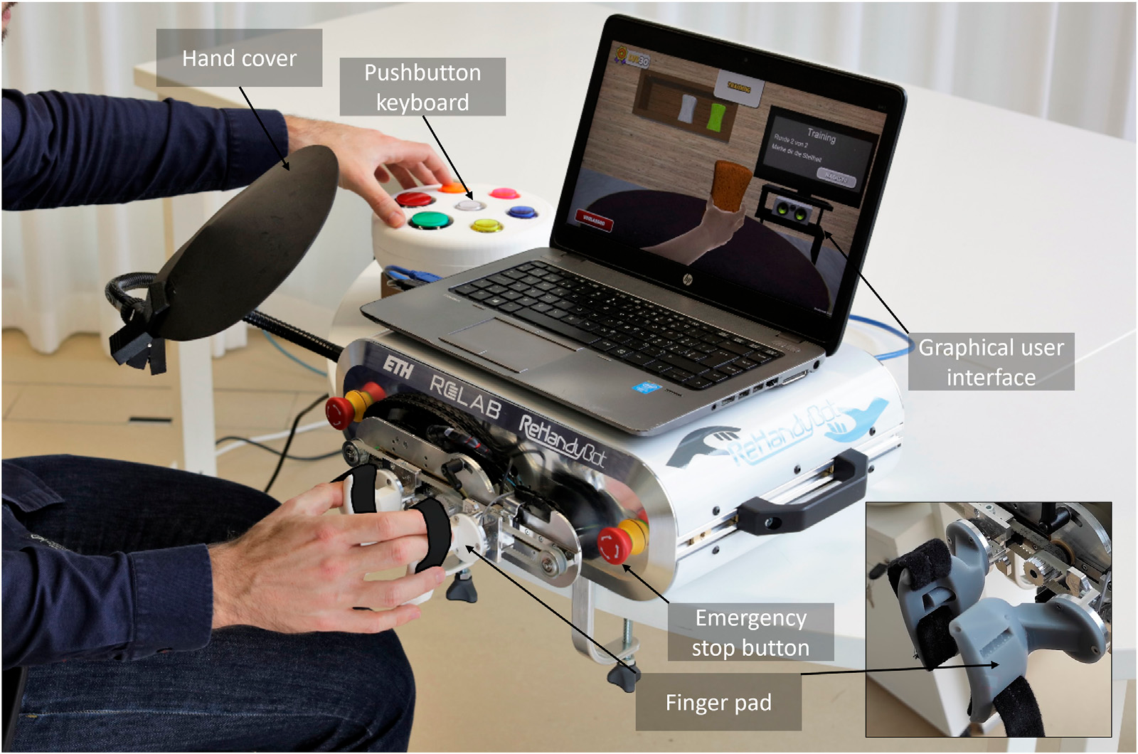
Figure 1. A subject performing the sponge exercise with the ReHandyBot. Components labelled include: hand cover, pushbutton keyboard, graphical user interface, emergency stop button, and ellipsoidal finger pads.
The ellipsoidal shape of the finger pads is a deliberate ergonomic choice: it accommodates patients with elevated muscle tone by preventing the fingers from slipping out of position during exercise, while allowing comfortable hand placement regardless of individual hand size or anthropometrics.
3. The Tone Estimation Method
The core contribution of this paper is a perturbation-based method for estimating muscle tone online, embedded seamlessly within a therapy exercise. During the natural pauses between exercise repetitions when the patient's hand is relaxed, and the robot applies brief 20 mm ramp-and-hold positional perturbations to the grasping DOF, stretching the long finger flexor muscles within their range of motion. The perturbation induced peak force at the fingertips is then used to compute end-point stiffness as a proxy for muscle tone.
Two perturbation speeds are used: fast (150 ms ramp duration) and slow (250 ms ramp duration). These time windows are not arbitrary. Fast perturbations are designed to capture the short-latency spinal monosynaptic stretch reflex, while slow perturbations capture the long-loop transcortical reflex. Together, the two speeds allow assessment of whether muscle tone is speed dependent; the hallmark of spasticity as defined by Lance (1980). Stiffness is computed as:
k = (F_peak − F_base) / a
where F_peak is the absolute peak force during the perturbation, F_base is the average baseline force over the 50 ms before ramp onset, and a is the perturbation amplitude (20 mm). Perturbations are applied approximately every three minutes, yielding up to three perturbation blocks over a 12-minute session.
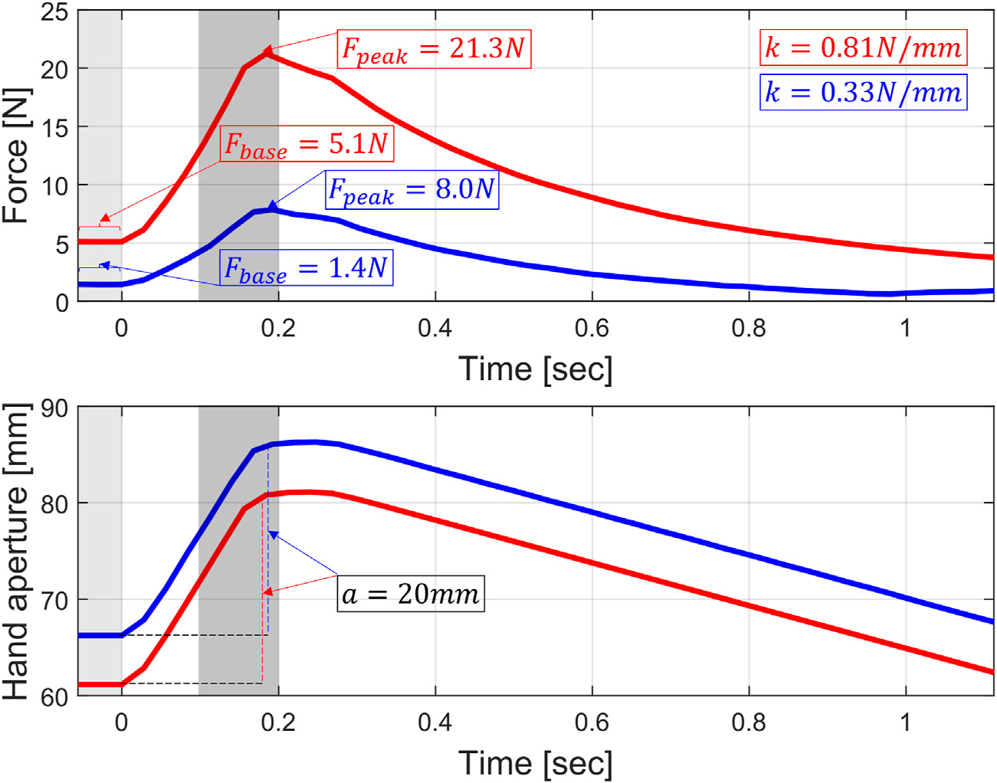
Figure 2. Representative fast ramp-and-hold perturbation. Red: stroke subject (F_peak = 21.3 N, k = 0.81 N/mm). Blue: unimpaired subject (F_peak = 8.0 N, k = 0.33 N/mm). Top: fingertip force [N]. Bottom: hand aperture [mm].
4. Therapy Exercise and Study Protocol
The tone monitoring method was embedded within a sensorimotor sponge exercise inspired by the neurocognitive rehabilitation approach of Perfetti. In this exercise, subjects squeeze virtual sponges of different stiffness rendered by the robot, memorise their properties during a training phase, and then identify them by colour during a test phase. Perturbations are applied between sponge interactions, during natural hand relaxation periods, making them largely imperceptible to the patient.
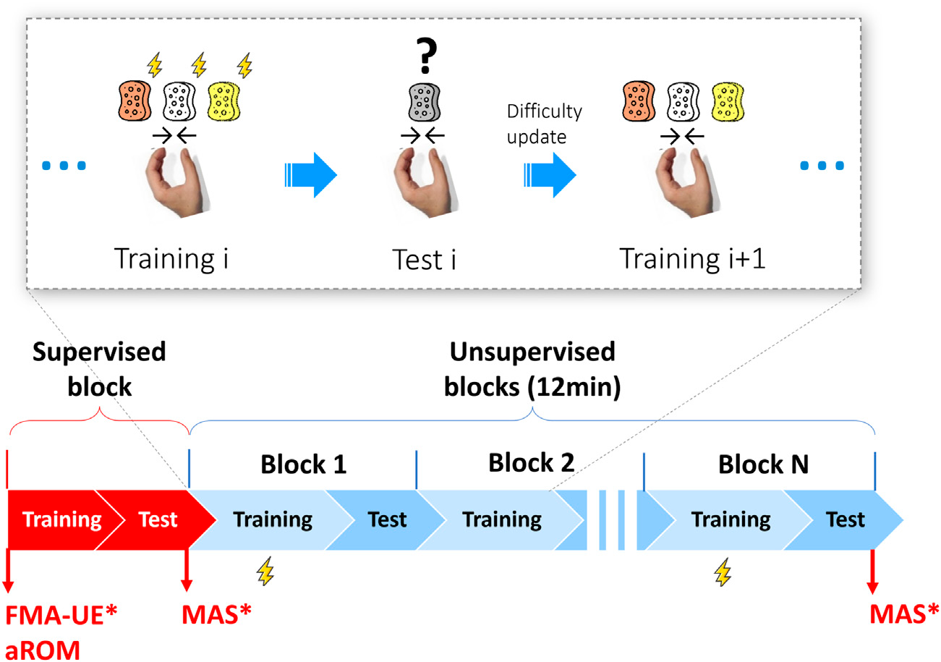
Figure 3. Exercise structure (top) and pilot study protocol (bottom). Perturbation blocks (⚡) are spaced at least three minutes apart within the 12-minute unsupervised session. MAS is assessed at the start and end for stroke subjects only.
The pilot study enrolled six chronic ischemic stroke patients with hand spasticity (MAS ≥ 1, mean age 64.3 ± 9.5 years, mean 141.8 ± 56.7 months post-stroke) and ten age-matched neurologically intact controls (mean age 59.9 ± 6.1 years). Each participant completed a single session consisting of one supervised familiarisation block followed by 12 minutes of simulated unsupervised exercise. The investigator observed from across the room and intervened only in cases of risk or upon request.
5. Testbench Validation
Prior to human testing, the authors validated the force measurement accuracy of the system using physical springs of known stiffness (0.97 and 1.57 N/mm) connected to the finger pads. Ten fast and ten slow perturbations were applied to each spring.
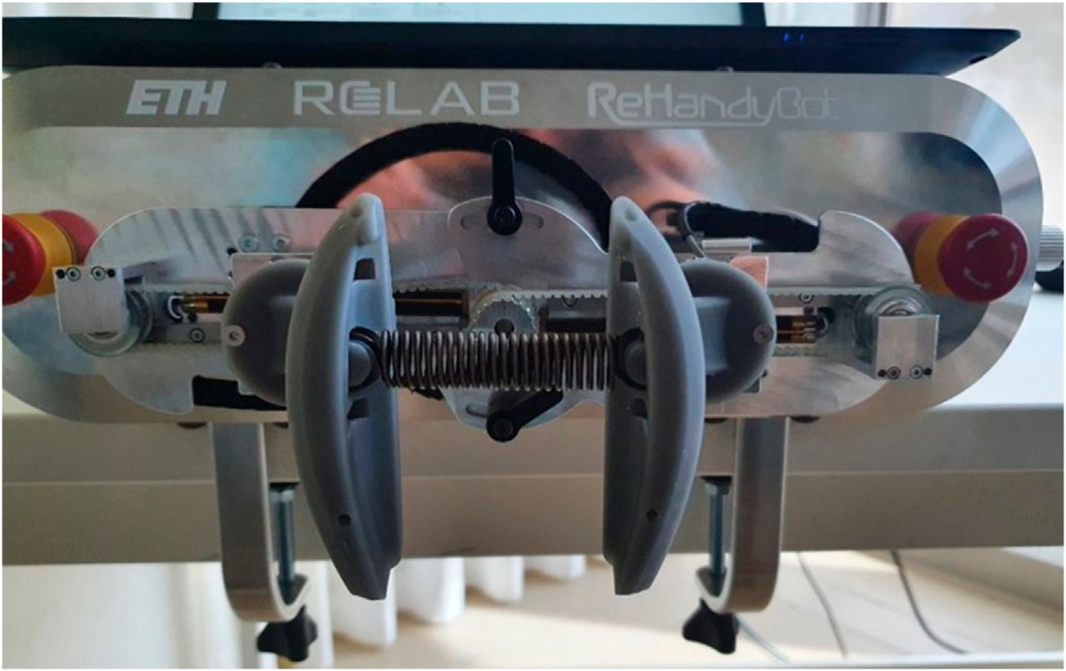
Figure 4. Setup for the stiffness identification experiment. Springs of known stiffness were connected to the finger pads via cylindrical constraints to validate perturbation-based force estimation.
The root mean square percentage error (RMSPE) was 3.8% (maximum 6.9%) for the soft spring and 11.3% (maximum 12.5%) for the stiff spring. Accuracy was not significantly different between the two perturbation speeds (p = 0.910). These errors compare favourably with other robotic devices designed for joint stiffness estimation, which report maximum errors of 15–25%. Since all participant force responses in the pilot study fell below the soft spring levels, the measurement error attributable to the device is estimated to be below 4%.
6. Results
All participants completed the protocol without adverse events. Two stroke subjects terminated the exercise early due to mild, transient finger pain; a known phenomenon in highly spastic hands during physical activity, and one unimpaired subject withdrew early due to feeling unwell on the day.
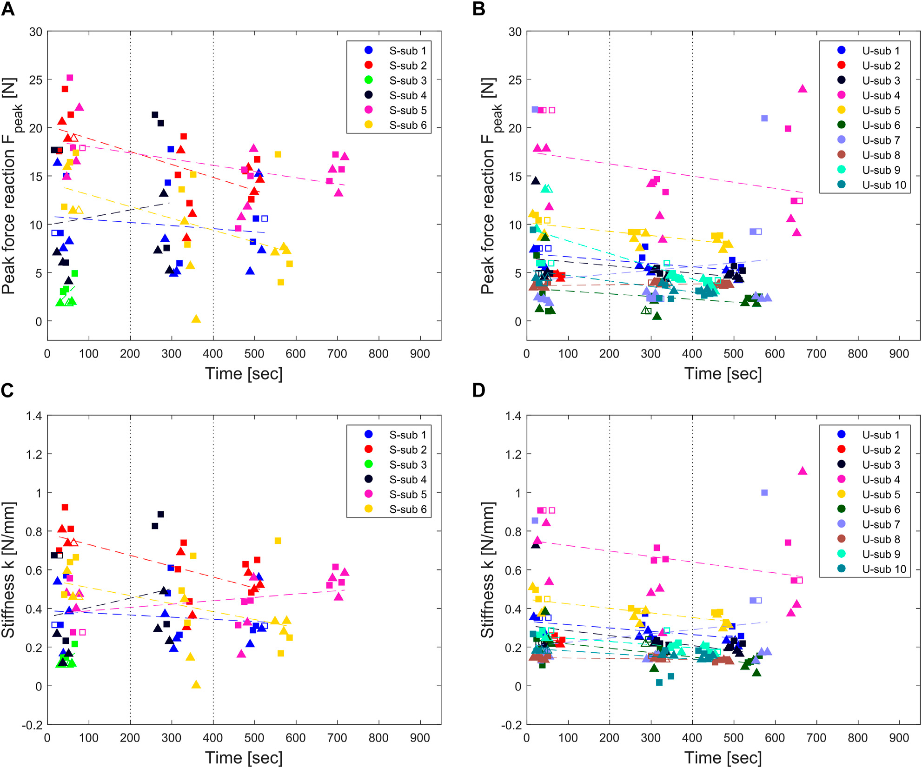
Figure 5. Individual peak force [N] (top) and stiffness [N/mm] (bottom) over exercise time for the stroke group (A, C) and unimpaired group (B, D). Triangles: slow perturbations. Squares: fast perturbations. Dashed lines: linear fit per subject.
Peak forces and stiffness values were significantly higher in the stroke group compared to the unimpaired group at both perturbation speeds (p < 0.0001). Average peak forces during fast perturbations were 13.7 ± 5.6 N (stroke) versus 6.8 ± 5.1 N (unimpaired); during slow perturbations, 10.7 ± 5.6 N versus 5.8 ± 4.2 N. End-point stiffness followed the same pattern, with the stroke group measuring 0.49 ± 0.21 N/mm (fast) and 0.38 ± 0.19 N/mm (slow), compared to 0.30 ± 0.21 N/mm and 0.25 ± 0.17 N/mm in the unimpaired group.
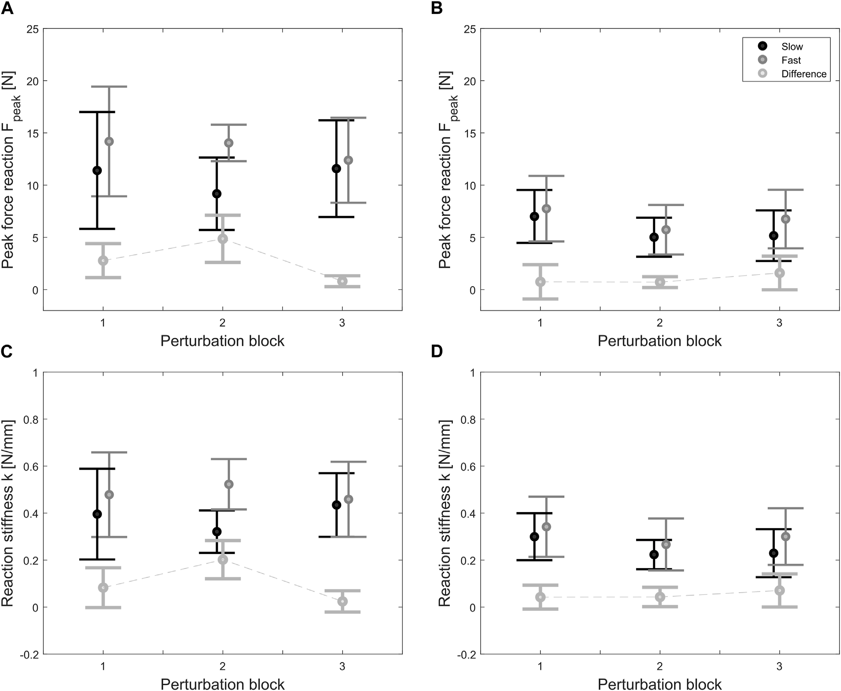
Figure 6. Average peak force (top) and stiffness (bottom) per perturbation block. Black: slow perturbations. Grey: fast perturbations. Dotted line: fast−slow difference (speed-dependency indicator). Left (A, C): stroke group. Right (B, D): unimpaired group.
Importantly, muscle tone did not increase significantly over the course of the exercise in either group. Four of six stroke patients and nine of ten unimpaired subjects showed a mildly decreasing tone trend over time. No statistically significant speed-dependency was found after Bonferroni correction in either group, likely due to the two perturbation speeds being relatively close to one another (40 vs. 67 mm/s). No correlation was found between robot-derived metrics and the MAS, which the authors attribute to the well-documented limited reliability and resolution of the MAS rather than any deficiency of the robotic method.

